Problem Statement: BloodNet-CRM-for-Blood-and-Plasma-Management

# Problem

Access to blood and plasma during emergencies is often delayed due to fragmented donor records, manual request handling, and lack of real-time visibility into inventory. Hospitals rely on outdated processes such as phone calls, paperwork, and disconnected databases, leading to critical time loss in life-saving situations. Additionally, donors are not effectively engaged, resulting in missed opportunities for timely donations and poor inventory management in blood banks..

# Proposed Solution

The proposed **BloodNet CRM** is a Salesforce-based system that centralizes and automates the entire blood and plasma management process, the solution provides:

* A **central donor registry** with blood group, eligibility status, and donation history.
* A **hospital request management system** to raise and track urgent needs.
* **Automated donor matching** to identify compatible donors instantly.
* **Email/SMS alerts** to donors and hospitals for faster communication.
* **Real-time inventory dashboards** to monitor blood stock and trends.
* **Reports and analytics** for healthcare administrators to make data-driven decisions.

This solution eliminates manual inefficiencies, accelerates emergency response, and improves donor engagement, ultimately saving lives and strengthening healthcare delivery.

# PHASE 1: Problem Understanding & Industry Analysis

### **Requirement Gathering**

The following key requirements were identified through analysis of existing challenges in blood and plasma management:

1. **Centralized Donor Records** – Store and maintain donor information, including blood group, eligibility, and donation history.
2. **Hospital Request System** – Enable hospitals and clinics to raise urgent requests for blood and plasma.
3. **Automated Donor Matching** – Match requests with compatible donors based on blood group and location.
4. **Communication Mechanism** – Provide automated alerts and notifications (SMS/Email) to donors and hospitals.
5. **Inventory Management** – Track available blood stock, plasma units, and expiry dates across multiple blood banks.
6. **Reporting & Analytics** – Generate dashboards and reports for monitoring trends, donor engagement, and fulfillment rates.

### **Stakeholder Analysis**

The solution involves multiple stakeholders, each with unique needs:

* **Donors** – Want a simple way to register, update their eligibility, and receive reminders/alerts.
* **Hospitals & Clinics** – Require a fast and reliable method to raise requests and track fulfillment.
* **Blood Banks** – Need to manage available stock, expiry dates, and donations efficiently.
* **Healthcare Administrators/Government Bodies** – Require reports and dashboards for decision-making and monitoring regional health preparedness.

### **Business Process Mapping**

The current manual approach involves phone calls, fragmented spreadsheets, and delayed coordination, which leads to inefficiency. The proposed CRM streamlines the workflow:

1. **Donor Registration →** Donor enters details such as blood group, contact, and last donation date.
2. **Hospital Request →** Hospital submits a requirement specifying blood/plasma type and urgency.
3. **Automated Matching →** CRM identifies compatible donors and notifies them.
4. **Inventory Update →** Stock levels are updated when requests are fulfilled.
5. **Reporting →** Dashboards display live statistics on requests, fulfillment, and inventory.

### **Industry-Specific Use Case Analysis**

* **Healthcare Context:** Emergencies such as road accidents, surgeries, or pandemics demand quick access to compatible blood and plasma.
* **Challenges in Industry:** Lack of integration between donor databases, inefficient communication, and outdated tracking methods.
* **CRM Advantage:** Salesforce CRM provides automation, real-time dashboards, and donor lifecycle management, which are missing in traditional approaches. This ensures faster emergency response and improved healthcare efficiency.

### **AppExchange Exploration**

* **Existing Apps:** Salesforce AppExchange offers generic healthcare and donor management applications (e.g., Health Cloud, fundraising solutions).
* **Gap Identified:** Most available apps are broad, complex, or costly, making them unsuitable for smaller hospitals and NGOs.
* **Proposed Differentiator:** **BloodNet CRM** is designed as a targeted, affordable, and scalable solution focusing exclusively on **blood and plasma management**..

# PHASE 2: Org Setup & Configuration

**1.Salesforce Editions**

We are using a Salesforce Developer Edition as the build and test environment for BloodNet CRM. This org provides full access to custom objects, Flows, Lightning App Builder, Reports & Dashboards required for the project.

## 

**2.Company Profile Setup**

Setup → *Company Settings* → **Company Information** → click **Edit**.

* + Company Name / Organization Name: BloodNet CRM
  + Default Time Zone: GMT+05:30 Asia/Kolkata
  + Default Currency: USD
  + Locale / Language: English (India)

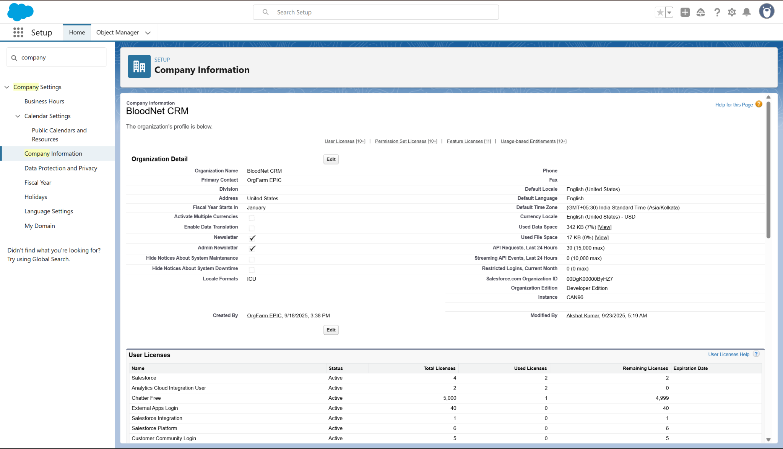

**3. Business Hours & Holidays**

**What to create / do**

* Define the operating hours and add important holidays.

**How (where to click)**

* Setup → *Company Settings* → **Business Hours** → **New**
  + Name: BloodNet Standard Hours
  + Time Zone: GMT+05:30 Asia/Kolkata
  + Working Hours: Mon–Sat 09:00 AM – 09:00 PM
  + Save.

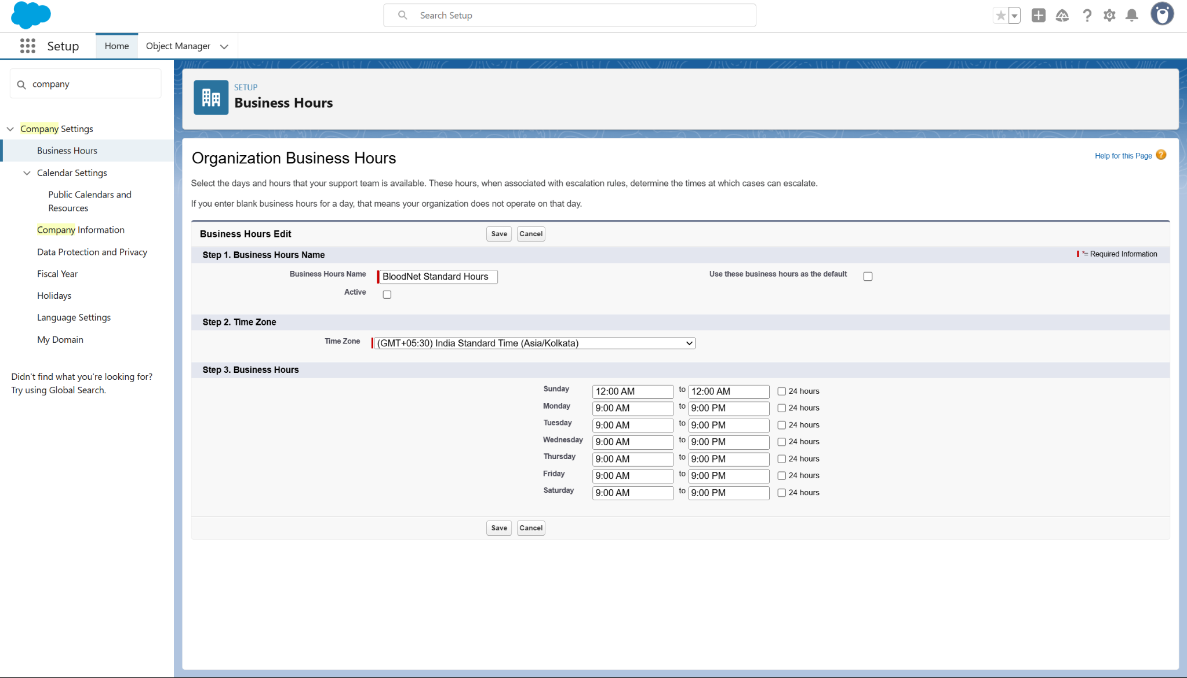

Setup → *Company Settings* → **Holidays** → **New Holiday** → add national holidays

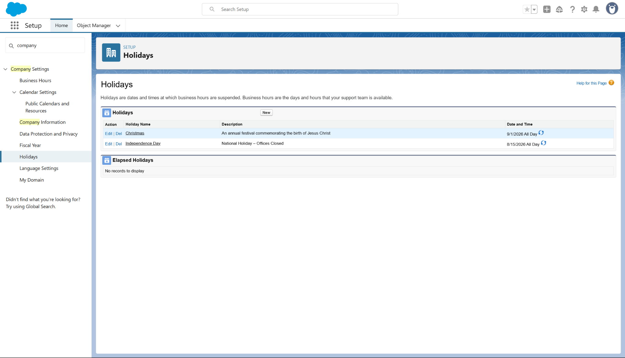

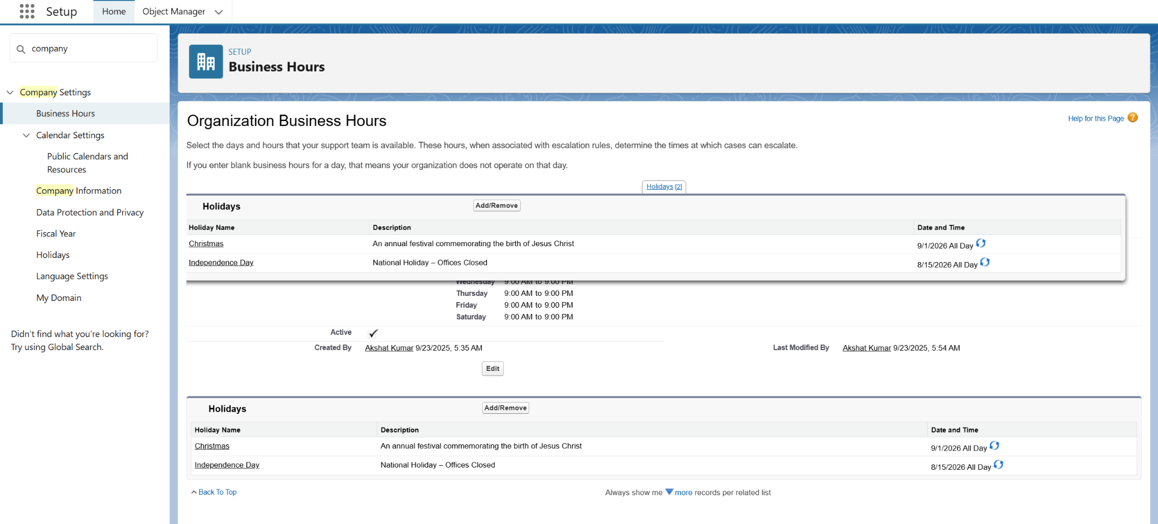

**4. Fiscal Year Settings**

Setup → *Company Settings* → **Fiscal Year** → ensure **Standard Fiscal Year** is selected

Fiscal settings are set to align statistical reports and year-on-year donor analytics with regional reporting cycles.

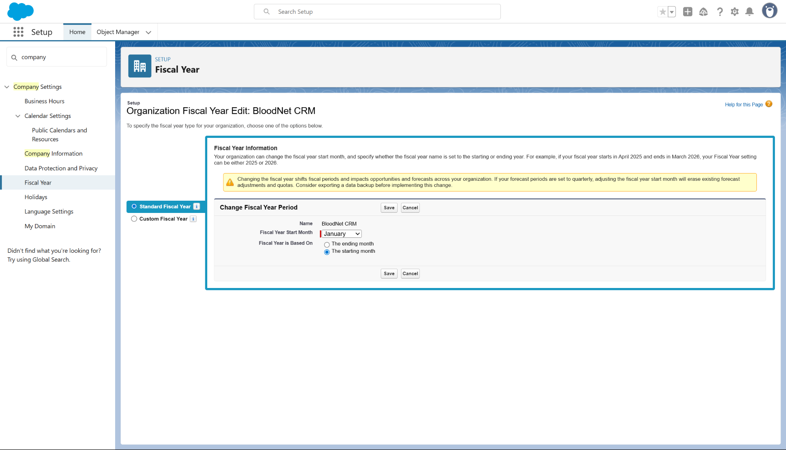

**4. User Setup & Licenses**

Profiles vs Roles vs Users (Quick Recap)

* Profile → Defines what a user can do (object access, field access, tabs).
* Role → Defines what records they can see (record visibility in the hierarchy).
* User → A person account in Salesforce, which is always assigned one Profile + optionally one Role.
* Created users:
  + System Administrator (Salesforce platform user)
  + Hospital Admin (Salesforce platform user)
  + Blood Bank Admin (Salesforce platform user)

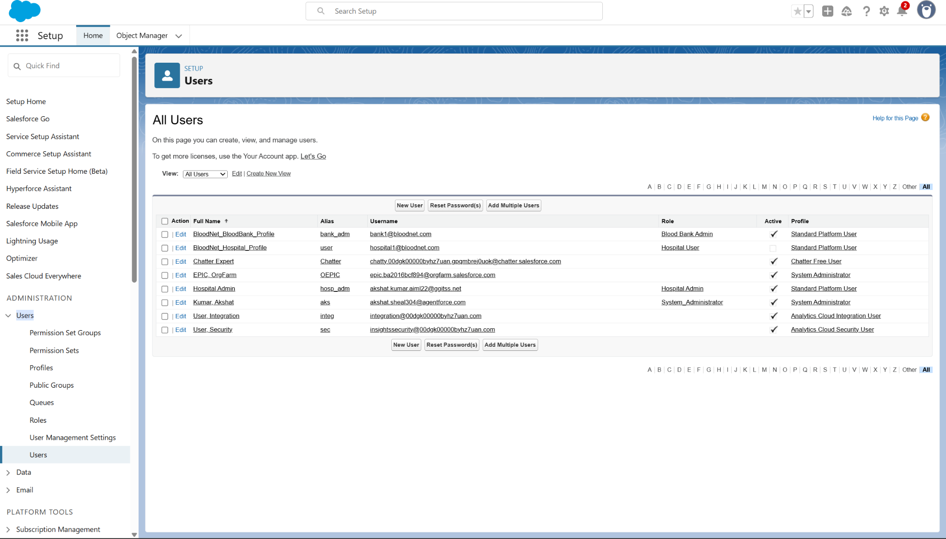

Setup → Users → Profiles → click Standard User (or another base) → Clone.

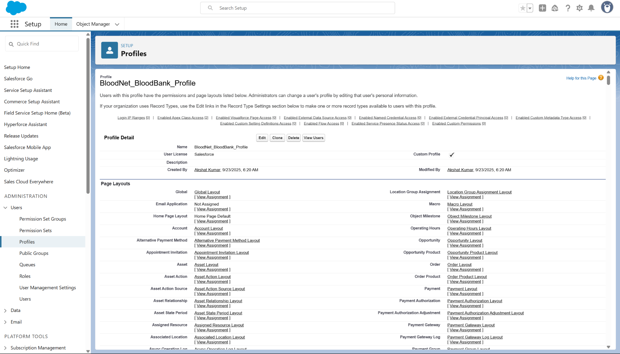

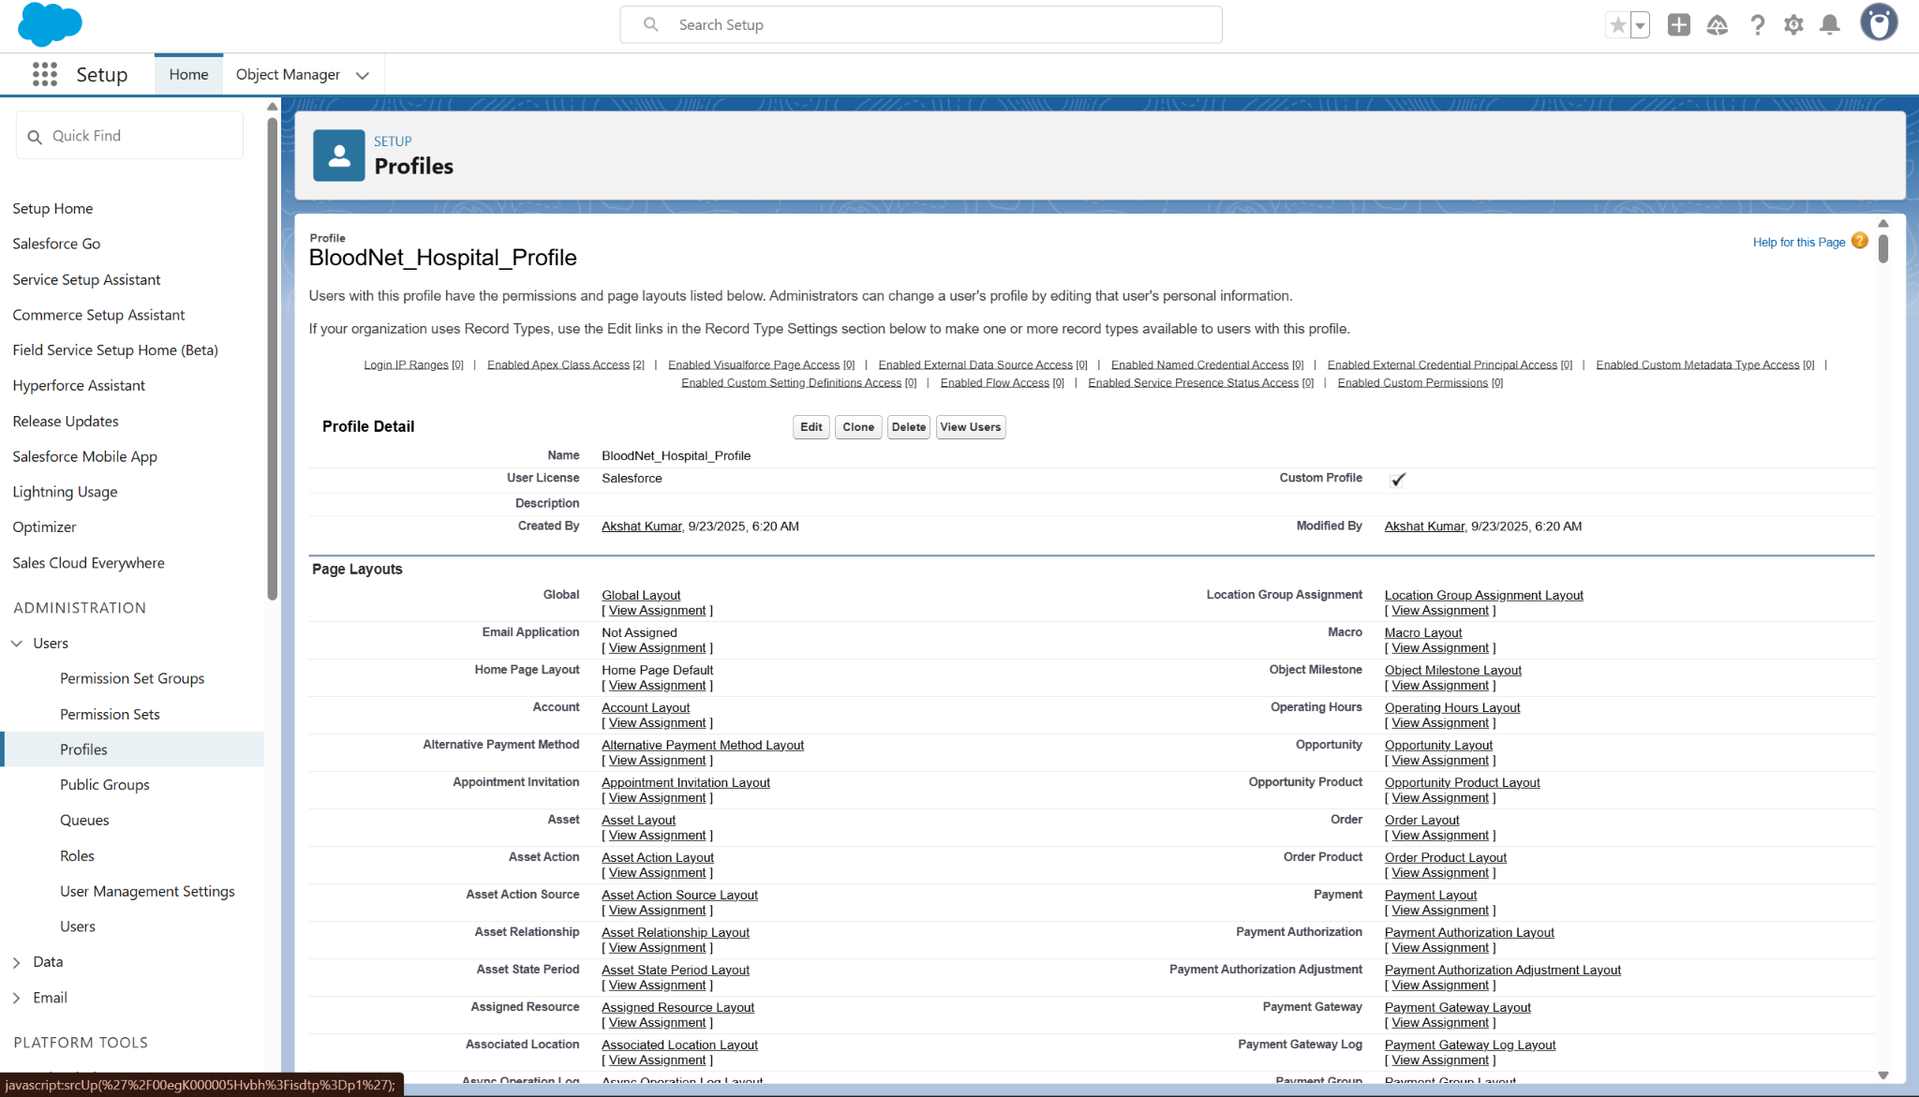

**6. Roles & Role Hierarchy**

Setup → *Users* → Roles → Set Up Roles → Click Add Role under desired parent.

* Create: System Admin (top), Hospital Admin, Hospital User, BloodBank Admin, Donor Agent.

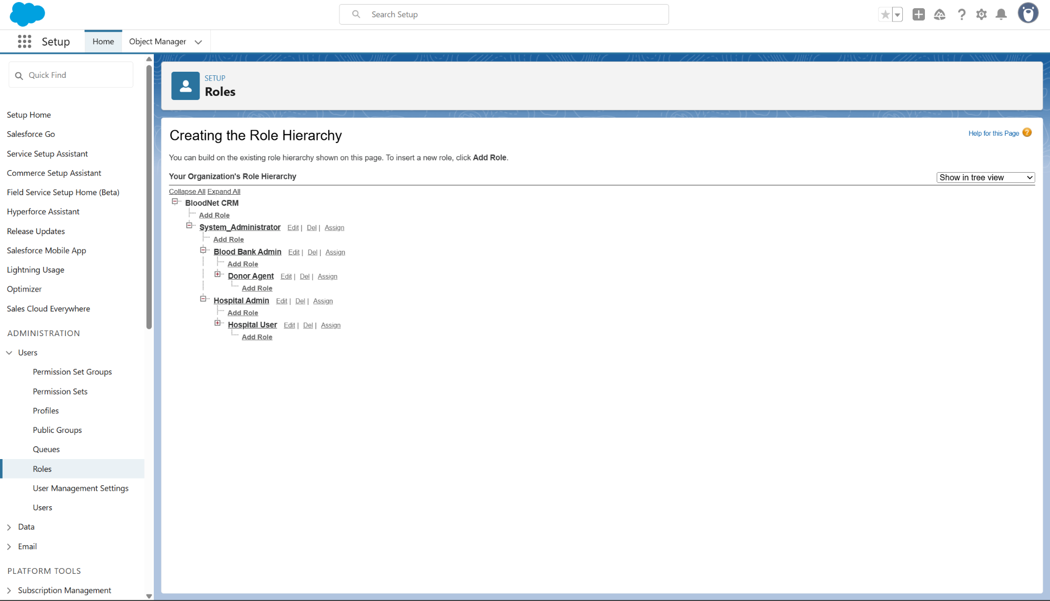

**7. Permission Sets**

**Why:** Profiles handle most access, but Permission Sets let you add **extra rights without cloning profiles**. This makes your design look scalable and professional.

**What to create:**

* Permission Set 1 → Reporting Access → gives access to Dashboards/Reports.
* Permission Set 2 → Donor Communication → gives access to send emails/notifications.

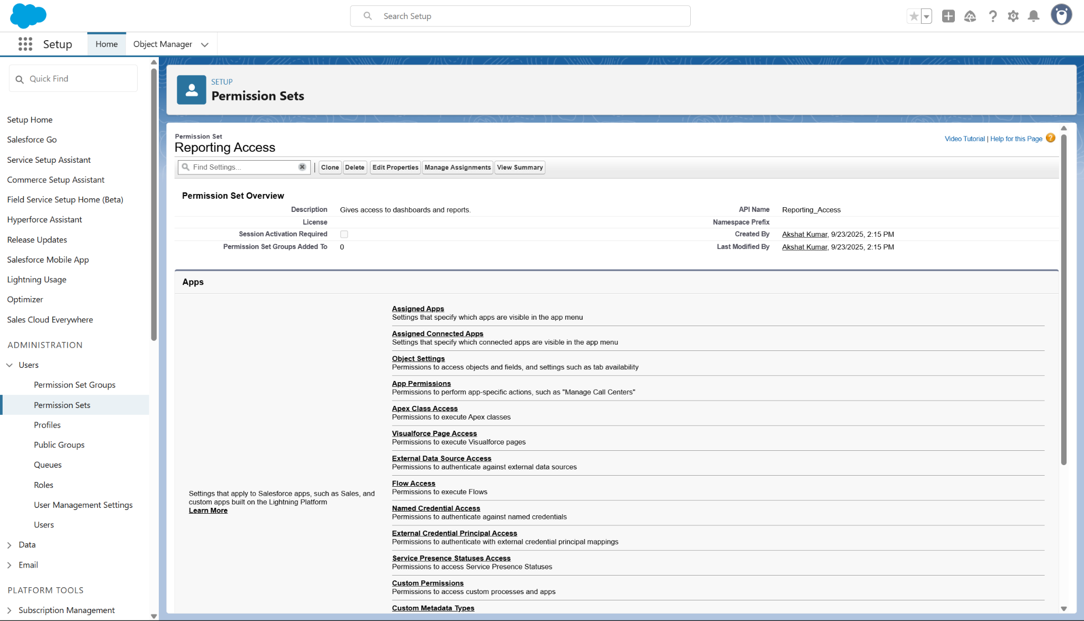

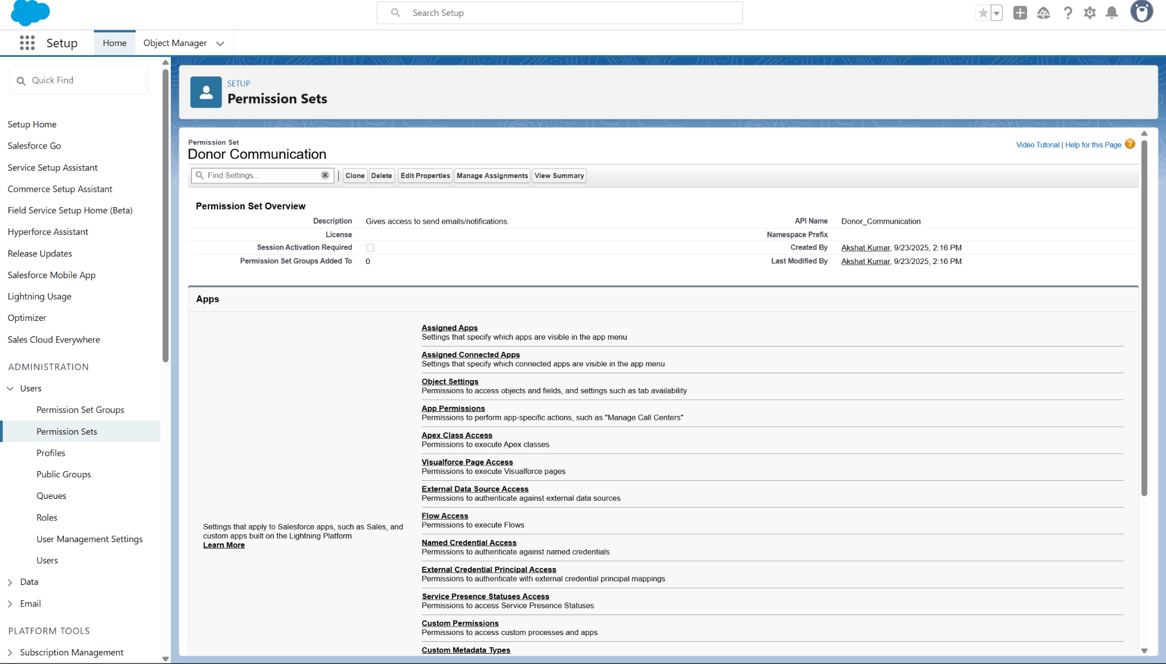

Assigned to **Hospital Admin** and **Blood Bank Admin** test users.

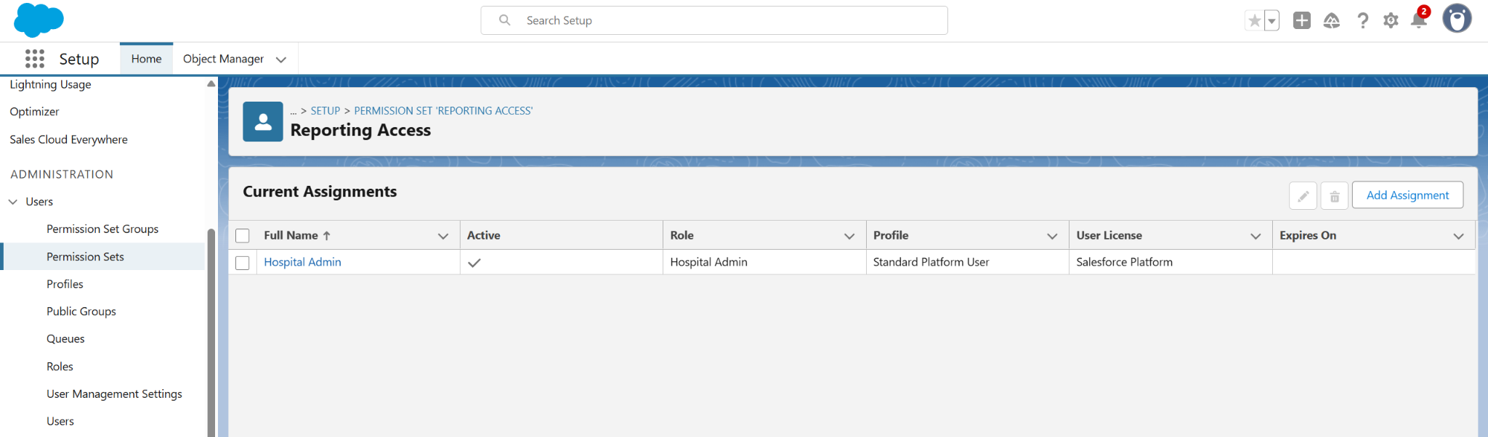

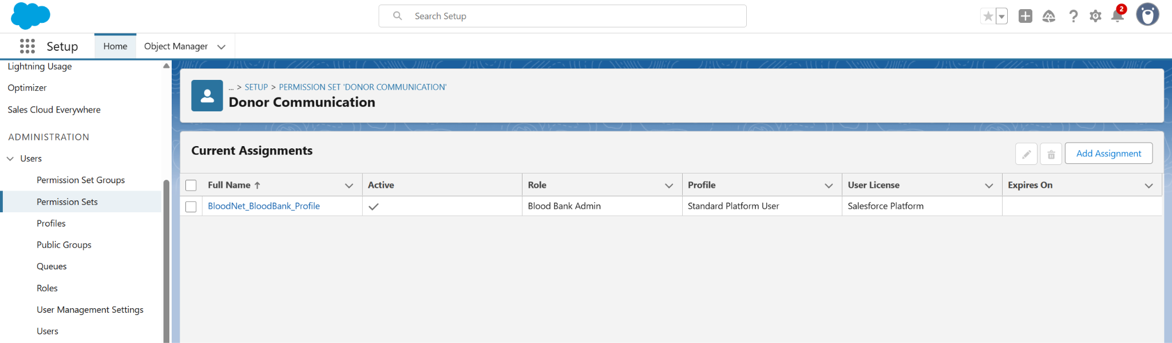

**8.Org-Wide Defaults (OWD)**

OWD is **core to security**.

This will be configured in Phase 3, as the settings need to be applied to the custom objects that will be created then.

**9.Login Access Policies**

Login Access Policies determine who can log in as a user and for how long. This is useful for admin troubleshooting and security monitoring.

Setup → Quick Find → **Login Access Policies**.

